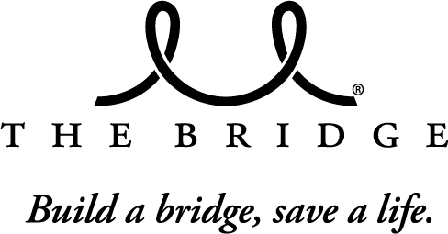  4000 Junius Street  Dallas, Texas 75246  (214) 821-3820 | 2015 A Night With The Bridge  SPONSOR FORM  February 21, 2015  The Empire Room  1225 N. Riverfront Blvd.  Dallas, TX 75207

Contact Information
Company Name: |  |  |  |  |  |  | Address:
Contact Name: |  |  |  |  |  |  | City, State, Zip:
Email: |  |  |  |  |  |  | Phone:
Sponsorship Levels for All Events
Presenting Sponsor
$15,000
Gold Sponsor
$10,000
Silver Sponsor
$7,500
Bronze Sponsor
$5,000
Friends of the Bridge Breast Network
$2,500

Pink Supporter
$1,000

Payment Information
Total Due: |  | $ |  |  | Check (payable to The Bridge Breast Network) Credit Card
Card Number: |  |  |  |  |  |  |  | Exp. Date: |  |  |  |  |  | Security Code:
Name on Card: |  |  |  |  |  |  |  | City, State:
Billing Address: |  |  |  |  |  |  |  | Zip Code:

