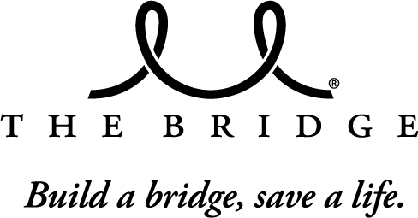
2015 A Night With The Bridge
ADVERTISING FORM
4000 Junius Street
Dallas, Texas 75246
(214) 821-3820
Saturday, February 21, 2015

Contact Information
Company Name: |  |  |  |  |  |  |  |  |  | Address:
Contact Name: |  |  |  |  |  |  |  |  |  | City, State, Zip:
Email: |  |  |  |  |  |  |  |  |  | Phone:
Business Ads
(Must be camera ready)
Full Page (5-1/2 x 8-1/2) | $250 |  |  |  |  |  |  |  |  | Half Page (5-1/2 x 4-1/4) | $150
Quarter Page (4-1/4 x 2-1/2) | $75
In Honor Of or Memory Of Ads
Full Page (5-1/2 x 8-1/2) | $150 |  |  |  |  |  |  |  |  | Half Page (5-1/2 x 4-1/4) | $100
Quarter Page (4-1/4 x 2-1/2) | $50
In honor of or In memory of
Any additional verbiage you wish to have printed
Submission must include Advertising Form, payment, your message, camera ready art and/or picture (if applicable). Submission deadline: February 6, 2015.
Payment Information
Total Due: |  | $ |  |  |  | Check (payable to The Bridge Breast Network) Credit Card
Card Number: |  |  |  |  |  |  |  |  |  |  | Exp. Date: |  |  |  |  | Security Code:
Name on Card: |  |  |  |  |  |  |  |  |  |  | City, State:
Billing Address: |  |  |  |  |  |  |  |  |  |  | Zip Code:

